Dear Guest

Health and safety for you and our staff are our utmost priority.

Therefore, we follow the rules and recommendations from the authorities concerning prevention of Covid-19 and we have launched a number of initiatives to make sure that you have a safe stay here with us.

Staff with corona passport
We ensure that all our staff have a valid corona passport. We have also made it clear to our staff that they must stay at home and be tested if they have any symptoms of Covid-19, and that they must follow the rules on isolation if they have been in close contact with anyone infected.

Frequent cleaning and disinfection
We have always had focus on good hygiene, but in order to prevent Covid-19, we have launched a number of additional measures: We have upgraded cleaning and disinfecting in common rooms and at contact points, for example table surfaces, door knobs and plugs.

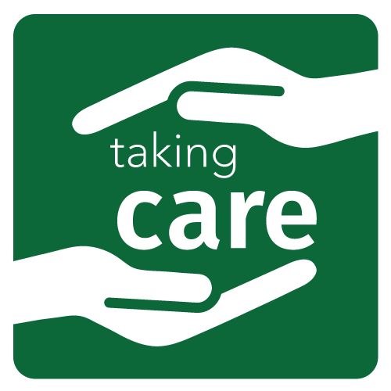
All our staff have been instructed in cleaning and disinfection, and we have enhanced cleaning procedures to ensure adequate and frequent cleaning and disinfection.

Frequent airing out
We have also placed higher priority on ventilation, and we air-out all common areas very often.

Good hand hygiene
We have instructed all our staff in good hand hygiene and made sure that both guests and staff have easy access to hand sanitizer as well as soap and wash basins.

What can you do as a guest?
As you can see, we have already taken care of almost everything. All that is left for you is to follow the general recommendations from the authorities:

- Postpone your visit if you have symptoms of Covid-19
- Keep your distance to other guests and staff
- Wash your hands often or use hand sanitizer

Note signs and instructions
There may be new measures that we have not mentioned here, so pay attention to signs and instructions. If you are in doubt, you are welcome to ask our staff.

We are aware that these measures may be a hassle now and then, but we hope that you understand that they are for your safety and for the safety of other guests and staff.

Yours sincerely

